CAMPBELLTOWN COLLEGIANS
MASTERS SWIMMING CLUB

2018 ANNUAL REPORT

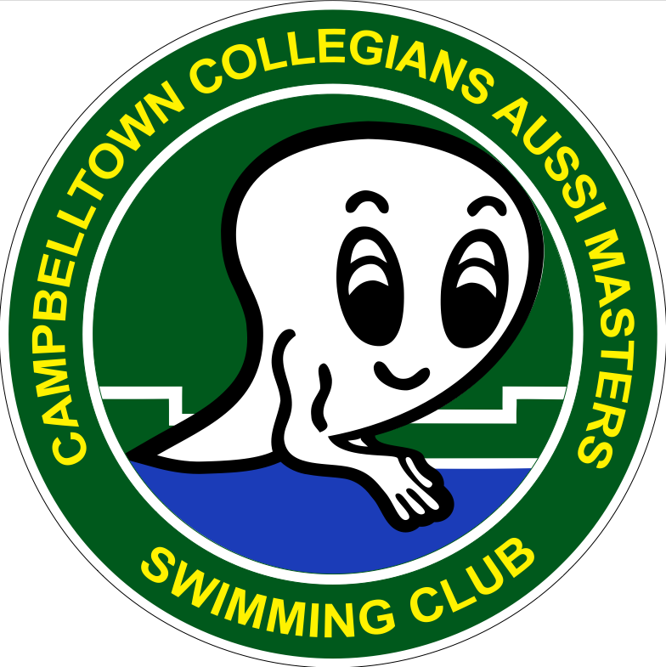

Bryan Ferry sang the classic song ‘Lets Stick Together’. So what? So, that’s precisely what we do at Campbelltown Masters Swimming Club – we stick together! We encourage each other, we help each other, we volunteer for each other, we step forward when things need to be done.

Our recent 2019 carnival was the perfect example of our wonderful club spirit. And it’s not just the club members who show this spirit; it’s our spouses, partners, children, family, friends, even prospective members (now full members); we all do it. Thank you for sticking together; this is the heart of our club.

No-one typified this spirit more than Hans Preiss who, out of swimming for six months with injury, still turned up every Sunday morning to time keep. “Its just part of what we do at this club” admitted Hans. “Even if we can’t swim, we still help out.”

2018 was a ‘different’ year for our club. After a record 18 consecutive years’ dominance as NSW endurance swimming champions, last year we were knocked off the top perch. We finished 2nd in NSW and 3rd nationally, so still a wonderful year. And coming second was the best thing that could happen to our club! Why? Our club membership was ageing and we needed new (especially younger) members.

So late 2018 was a huge and refreshing time of new recruits: Sharon Carpenter, Laura Lawrence, Janette Towel and Fiona Woods, who joined in January 2019 by Jenni Goodhew, Kyle O’Brien, Brian Sutton and Paige Tomkins. Welcome aboard.

Suzie Haddad, who joined in 2017, was ecstatic about the newcomers. “This is the best thing that could happen to our club!” exclaimed Suzie. “Now we’ll have lots more going to carnival and swimming relays.” And Suzie was spot-on with her judgment as most have competed at the first two carnivals of the year.

Campbelltown’s Sunday morning swims are the backbone of our club – and always attract most members for relaxed (but still energetic) competition. We are unique in masters swimming clubs around Australia as no other club competes like this. No wonder our club spirit is so high.

The Sunday swims - and attendance at carnivals – all contribute to the Club Champion award, plus other trophies like Most Improved, Encouragement Award, etc. Unfortunately, the secrecy surrounding the winners over the past three months is so tight even Mr President isn’t told. The announcement must wait, as always, for our club presentation BBQ.

If our Sunday swims are our club’s backbone and club spirit our heart – then the sense of humour gene/gland/organ would have to be our social events! Someone mentioned the word ‘multitude’ but that would be an understatement for the number of social outings. Even our Sunday morning swims are social events – poolside chats interrupted by having to swim, cake-and-coffee, members turning up just to visit; its all very social.

Lesley and Mark Thompson are the social sparks, heading up the year with their annual Australia Day BBQ celebration. Our carnival was next, a social event we share with the state. A performance by Grace Knight at the Casual Powerhouse Museum followed, then a Saturday walk to/around Manly, then Heather and Terry Rouen hosted our presentation BBQ.

We always celebrate members’ Big 0 birthdays, so scattered through the year Greg Jacques, Elly Ramon, Linda Beveridge, and Sue Heins all (hopefully) enjoyed reaching another decade. Mt Annan Botanic Gardens, Campbelltown Regional Art Gallery and the Dragonfly Café at Mt Annan were the venues chosen.

Live shows are big on our list of social activities, with The Music of the Carpenters, Donna Lee Sings Petula Clarke, and The Piano Man at Casual Powerhouse. All Hail Chuck Berry at Campbelltown RSL, Elvis an American Trilogy at Mittagong RSL, The Book of Mormon in Sydney, and The Wharf Review at Wollongong Performing Arts Centre, along with respective lunches or dinners, were thoroughly enjoyed.

Every three months the club’s ladies, friends, wives, etc. had lunch together. Another walk, this time around Rose Bay, Woolloomooloo and the Royal Botanic Garden, was well attended, as were the end of-year events – Christmas breakfast at Campbelltown Performing Arts Centre and the final BBQ of the year hosted by Annie and Doug Cooke. Whew! What a list.

The future looks very promising for Campbelltown Masters Swimming. We are leading the way in forming a new endurance swimming category, which has more than a little interest shown by other clubs – and NSW and Australian Masters Swimming organisations! There’s also a list of suggestions/strategies/objectives that we have to improve our club and attract new members.

Finally, thanks to some organisations – Campbelltown Amateur Swimming Club for their unwavering support whenever we host a swim meet; Campbelltown Catholic Club for their continued sponsorship; and to Masters Swimming NSW’s President Kerryn Blanch and Administrator Jillian Pateman, plus the Board members, for their wonderful support - thank you!

Gregory Jacques
President

Photo 1 Our 4 million-metre-man, Mark Thompson, proudly displaying his award. That’s 80 000 laps!

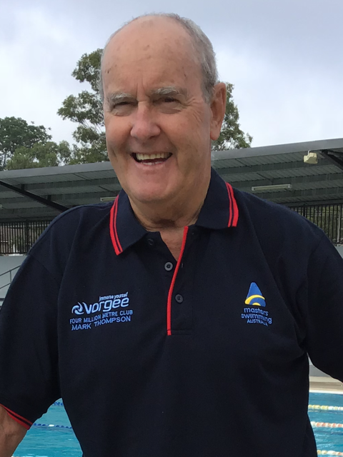

Photo 2 Campbelltown Carnival 2019 with an unexpected star-of-the-show… Duckie-the-Referee stayed poolside for the entire 6-hour carnival

