Campbelltown Collegians Aussi Masters Swimming Club

Endurance Swimming Recorder
2018 was a very satisfying year. It was also a very different year. Since the inception of the Masters Swimming NSW Trophy for highest average points per swimmer way back in 2000, there has been just one name on the trophy – Campbelltown Collegians. Now there is a second name, congratulations to Castle Hill Masters. Still, 18 years as Number 1 in the state cannot be bettered in any sport.
The good part about not winning (2nd place in NSW and 4th place nationally is outstanding!) is the influx of new members into our club late in the year. This bodes very well for the future of Campbelltown Masters Swimming Club, as the new members are enthusiastic about distance swimming.
I am very proud of everyone. I believe this is a great result and, with our new members participating, we will be back bigger and stronger in 2019 to challenge the larger clubs.
Club Code | NCT
Club Name | Campbelltown Collegians AUSSI MSC Inc
Total Points | 12136
Female Points | 5975
Male Points | 6161
Endurance 1000 Participants | 28
Female Participants | 17
Male Participants | 11
Total Club Members | 28
Lindsay Risk Club Secretary

Total Points

From the information below you can see that we came 4th in the country (with only 28 swimmers!) and 2nd in the NSW (competing against Tuggeranong with 97 members).
National Total Points
Club Code | Club Name | Points | Average Points | F-Points | M-Points | Participants | Female | Male | Members
QNA | Noosa Masters Swimming Club Inc | 22497 | 255.65 | 12513 | 9984 | 65 | 38 | 27 | 88
TTL | Talays Masters | 17032 | 516.12 | 10248 | 6784 | 33 | 17 | 16 | 33
NTN | Tuggeranong Masters Swimming ACT Inc | 16911 | 174.34 | 13430 | 3481 | 41 | 28 | 13 | 97
NCT | Campbelltown Collegians AUSSI MSC Inc | 12136 | 433.43 | 5975 | 6161 | 28 | 17 | 11 | 28
QMM | Miami Masters Swimming Club Inc | 12040 | 102.03 | 8917 | 3123 | 74 | 38 | 36 | 118
NBT | Blacktown City Masters Swimming Inc | 10720 | 238.22 | 6191 | 4529 | 38 | 21 | 17 | 45
WCM | Claremont | 9750 | 78.63 | 3012 | 6738 | 68 | 33 | 35 | 124
CDW | Darwin Stingers | 9367 | 76.15 | 5989 | 3378 | 46 | 32 | 14 | 123
VMV | Malvern Marlins | 8918 | 52.77 | 5834 | 3084 | 76 | 42 | 34 | 169
WSM | Somerset | 8505 | 193.30 | 4210 | 4295 | 26 | 13 | 13 | 44
VSP | Surrey Park Seahorses | 8132 | 193.62 | 3972 | 4160 | 19 | 8 | 11 | 42
NWS | Wests Auburn Masters Swimming Club Inc | 6635 | 390.29 | 3570 | 3065 | 13 | 5 | 8 | 17
QIP | Ipswich City Masters Swimming Inc | 6188 | 309.40 | 1014 | 5174 | 14 | 5 | 9 | 20

State Total Points
Club Code | Club Name | Points | Average Points | F-Points | M-Points | Participants | Female | Male | Members
NTN | Tuggeranong Masters Swimming ACT Inc | 16911 | 174.34 | 13430 | 3481 | 41 | 28 | 13 | 97
NCT | Campbelltown Collegians AUSSI MSC Inc | 12136 | 433.43 | 5975 | 6161 | 28 | 17 | 11 | 28
NBT | Blacktown City Masters Swimming Inc | 10720 | 238.22 | 6191 | 4529 | 38 | 21 | 17 | 45
NWS | Wests Auburn Masters Swimming Club Inc | 6635 | 390.29 | 3570 | 3065 | 13 | 5 | 8 | 17
NCM | Clarence River Masters | 4277 | 57.80 | 1827 | 2450 | 49 | 27 | 22 | 74
NPM | Port Macquarie Masters Swimming Club Inc | 3905 | 100.13 | 2594 | 1311 | 22 | 13 | 9 | 39
NBM | Blue Mountains Phoenix | 3714 | 206.33 | 3704 | 10 | 10 | 9 | 1 | 18
NCL | Castle Hill RSL | 3221 | 644.20 | 2710 | 511 | 5 | 3 | 2 | 5
NCH | Coffs Harbour Masters Swimming Club | 3210 | 152.86 | 2555 | 655 | 14 | 10 | 4 | 21
NCN | Molonglo Water Dragons | 2483 | 42.08 | 526 | 1957 | 6 | 2 | 4 | 59
NWG | Warringah Masters Swimming Inc | 1670 | 19.42 | 134 | 1536 | 28 | 9 | 19 | 86
NRY | Ryde Aussi Masters Swimmers (Rams) Inc | 1338 | 23.07 | 1233 | 105 | 15 | 10 | 5 | 58

Average Points
As you can see we can 3rd in the average points for the state and 3rd nationally
National Average Points
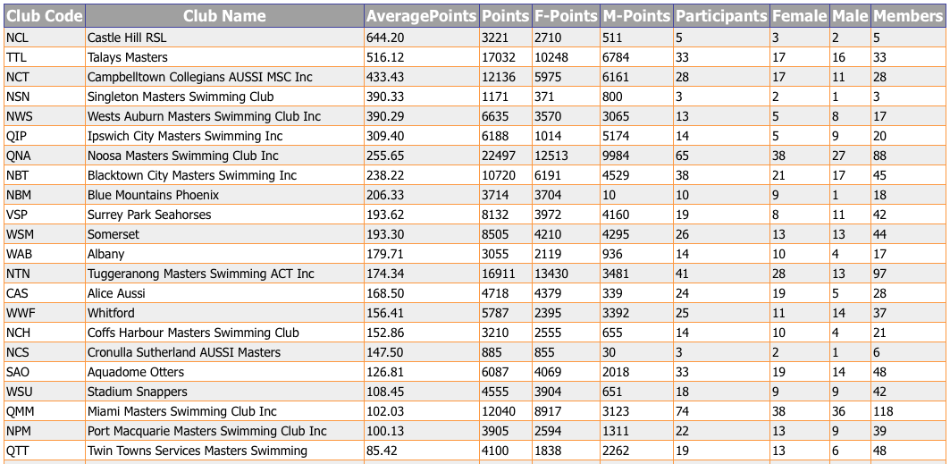

State Average Points
Club Code | Club Name | Average Points | Points | F-Points | M-Points | Participants | Female | Male | Members
NCL | Castle Hill RSL | 644.20 | 3221 | 2710 | 511 | 5 | 3 | 2 | 5
NCT | Campbelltown Collegians AUSSI MSC Inc | 433.43 | 12136 | 5975 | 6161 | 28 | 17 | 11 | 28
NSN | Singleton Masters Swimming Club | 390.33 | 1171 | 371 | 800 | 3 | 2 | 1 | 3
NWS | Wests Auburn Masters Swimming Club Inc | 390.29 | 6635 | 3570 | 3065 | 13 | 5 | 8 | 17
NBT | Blacktown City Masters Swimming Inc | 238.22 | 10720 | 6191 | 4529 | 38 | 21 | 17 | 45
NBM | Blue Mountains Phoenix | 206.33 | 3714 | 3704 | 10 | 10 | 9 | 1 | 18
NTN | Tuggeranong Masters Swimming ACT Inc | 174.34 | 16911 | 13430 | 3481 | 41 | 28 | 13 | 97
NCH | Coffs Harbour Masters Swimming Club | 152.86 | 3210 | 2555 | 655 | 14 | 10 | 4 | 21
NCS | Cronulla Sutherland AUSSI Masters | 147.50 | 885 | 855 | 30 | 3 | 2 | 1 | 6
NPM | Port Macquarie Masters Swimming Club Inc | 100.13 | 3905 | 2594 | 1311 | 22 | 13 | 9 | 39
NOF | Oak Flats Aussi Masters Inc | 84.38 | 675 | 530 | 145 | 8 | 5 | 3 | 8
NPN | Penrith AUSSI Masters | 79.60 | 796 | 746 | 50 | 3 | 1 | 2 | 10

